# **Python Automation Blueprint**

# **( Web + API ) - Selenium + Rest API**

## **Python**

* Install PyCharm IDE
* Introduction to Python Programming
* Working with Data Types
* Variables and Operators in Python
* Conditions and Loops
* Functions and String and List
* Tuples in Python
* Dictionaries in Python
* Loops in Python
* Functions in Python
* Classes and Objects
* Inheritance, Polymorphism, Abstractions
* Constructor
* Reading a file in python
* Writing to a file in python
* Exception Handling
* Array and Stack
* Singly Linked Lists

## **Topics and Projects ( API Testing)**

* Client-Server Architecture Presentation
* HTTP Basics, HTTP Methods
* What is an API?
* What is API Testing?
* Difference between API testing and Unit testing
* What is Web services?
* HTTP Structure, Type of Defects in API Testing
* Learn What is xml and JSON?
* URI and URLTools for API Testing
* Introduction to REST Web services.
* SOAP Introduction
* Why learning REST is Important?
* Difference between SOAP and REST Web services.
* REST constraints , Introduction to POSTMAN tool and installation.
* Creating requests in Postman.
* Creating collections in Postman.
* Understanding variables and environments in Postman.
* Authorization in POSTMAN
* Assertions/Test scripts in POSTMAN.
* Command line integration with Newman.
* Running POSTMAN Collection on Docker, Jenkins
* What is JSON Schema Validation?
* How to perform JSON Schema validation?
* Data Driven Testing with CSV with POSTMAN
* Exploring POSTMAN More features Mocking, Stabbing Testing
* GraphQL with POSTMAN
* Testing Websoctks with POSTMAN
* Writing API Test cases & Test Plan
* Running Testcases with POSTMAN
* Writing API Test cases & Test Plan
* Running Testcases with POSTMAN
* Advance JSON Schema
* LIVE API Testing Example

## **REQUEST Module**

* Introduction.
* Python Request Module.
* The GET Request.
* The POST Request.
* Status Code.
* JSON Response.
* Request Header.
* The Message Body.

## **PyTest**

* Install pytest
* Create your first test
* Run multiple tests
* Assert that a certain exception is raised
* Group multiple tests in a class

## **Selenium with Python**

* What is Selenium
* Why Selenium? / Advantages
* What are its versions?
* What all OS, Browsers, and Programming Languages does it Support?
* Java-Selenium Architecture
* Selenium vs Playwright vs Cypress
* WebDriver Architecture , Selenium IDE, Selenium Grid 3, 4
* Basic Selenium Program to Open and close Browser
* Runtime Polymorphism Program in Selenium WebDriver abstract methods
* Locators XPath, its Types and cases.
* Handling Multiple Elements
* Handling Synchronization issue by using implicitly Wait and Explicit Wait
* Handling Dropdown (static and dynamic)
* Handling Keyboard and Mouse Actions
* Taking Screenshot, Handling Disabled Element , Performing Scroll down
* Action Web Element Interface Methods, Handling Popups (web-based and Window-based), Shadow DOM, SWeb tables
* Handling Frames and Handling New Windows/New Tabs
* Custom Automation Framework
* New Selenium 4.11.2
* Cloud Testing - BrowserStack Demo

## **CI/CD - Jenkins**

* Install Jenkins
* Understand the Pipeline and Freestyle Jobs
* Install Plugins and Creating Freestyle Job.
* Run API Automation via Jenkins
* Run Selenium Automation via Jenkins
* Trigger job via Hook
* Post build Actions, Email Report

## **Learning GIT**

* Install Git into the System
* What is GIT?
* Why Use Git?
* GIT vs Github vs Gitlab Git Architecture
* Configuring Git
* .git Directory Commands
* Creating a new repository
* Checking the status Commiting
* Blame and Remote repositories
* Connecting to a remote repository
* Cloning a repository
* Getting changes from a server Branches
* Creating new branches
* Switching branches
* Merging branches Merge and Rebase
* TEMPORARY COMMITS
* Little Advanced Reference and Download PDF

## **Robot Framework**

* What is Robot Framework and its advantages
* Install Robot Framework with Python.
* Robot Framework Tests with Keywords & Variables
* Selenium Functional Automation using Robot Framework Keywords
* DDT (Data Driven Testing) & Parameterization the Selenium Tests using Robot Framework
* Customer Selenium keywords from Python Libraries in the Robot Framework
* Organize Robot Test files with POM (Page Object) Design Pattern.
* Parallel test execution and reporting in Robot Framework with plugins.
* Implement Tagging, filters and CI/CD Jenkins Integration for Automation tests
* Guideline to perform API Testing with Robot Framework

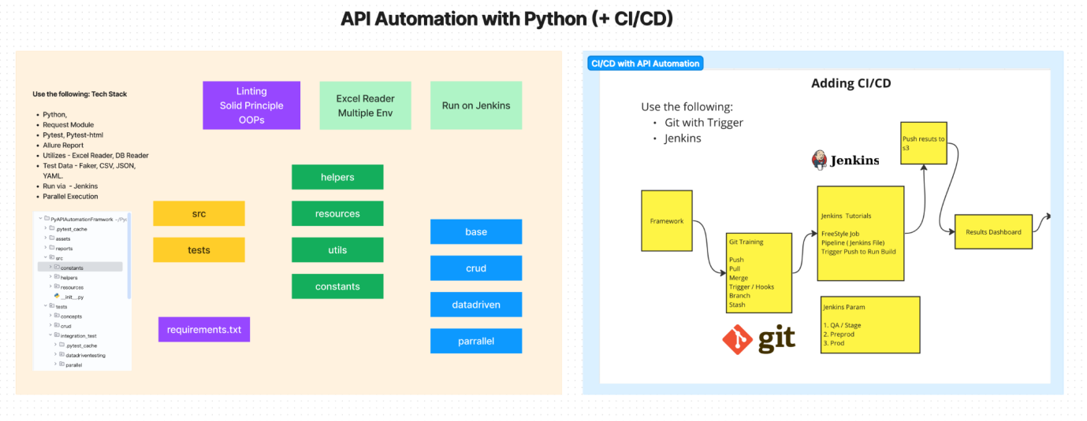

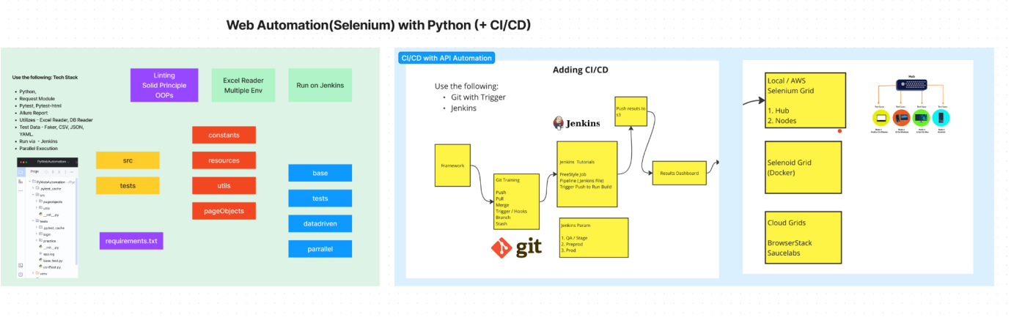**Learn Playwright with Python**

1. What is a Playwright?
2. Feature of Playwright
3. Python Basics
4. Installation of Python 3.x?
5. Install Py Charm
6. Playwright Architecture
7. Test Generators with Record and Play
8. Understanding the Playwright Code
9. Write Playwright Test
10. Locators
11. Xpath and CSS Selectors(Xpath Axes)
12. Actions with Playwright
13. Shadow Dom SVG
14. Javascript (page.evaluate)
15. Test Assertions
16. WebTables
17. Maximum Window, Locators, Fixture with python
18. Taking ScreenShots (+Failure)
19. Trace Viewer
20. API testing & Mock APIs
21. Reuse States Download Files
22. Test Isolation
23. Allure Report with PyTest
24. CI/CD ( Git and Jenkins Run)
25. End to End LIVE Project #1
26. End to End LIVE Project #2